JOB TITLE: Director of Downtown Development
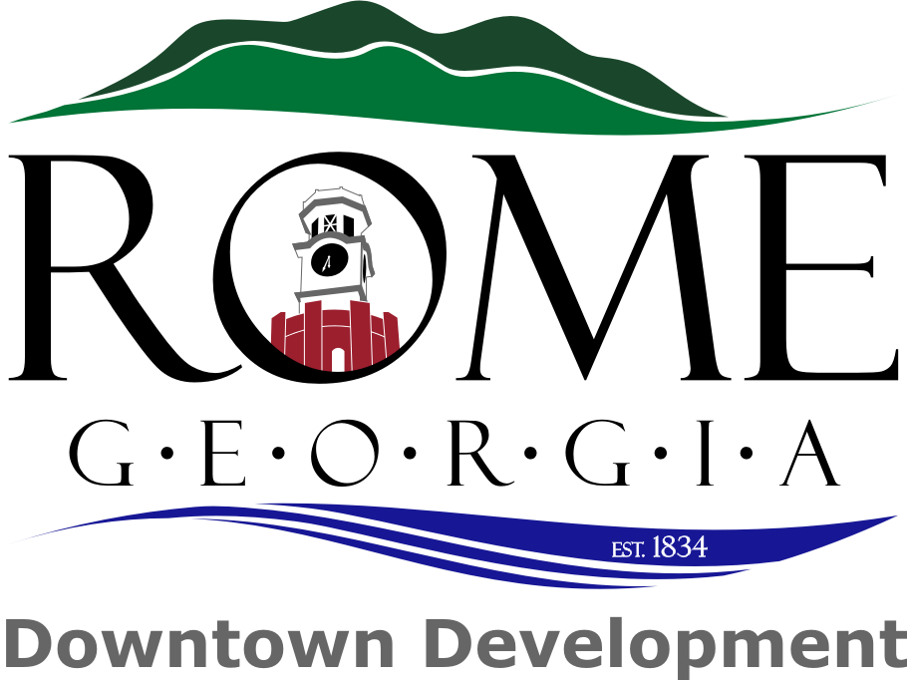

DEPARTMENT: Downtown Development

JOB SUMMARY: This position is responsible for planning, marketing, promoting, and implementing downtown development programs. The program objectives include community education, formulation of policies, and the development of marketing strategies for those areas. This program will be designed to promote, enhance, conserve, monitor, and improve downtown.

MAJOR DUTIES:
- Develops an annual budget and monitors expenditures.

- Develops, coordinates, and implements long and short range master plans for downtown development, including urban and trail development.

- Maintains inventories of existing resources, including mapping and photography.

- Develops an annual Downtown Development Authority work plan in coordination with community leaders and the RDDA Board, as well as with the Assistant City Manager.

- Provides assistance to and coordination of the RDDA Board, including administration and budgeting, agenda setting, committee formation and management, as well as volunteer recruitment and management.

- Coordinates with existing City and County departments, Tourism, Recreation Authority, state and federal agencies involved in planning, historic preservation, and downtown development.

- Plans and implements a variety of educational and public relation activities to create and maintain the historic central business district, including activities that will stimulate the economic development and incorporate historic preservation principles into revitalization of the downtown.

- Manages downtown parking programs, including supervision of the Parking Services Manager. Develops and improve existing parking programs.

- Communicate and coordinate building design elements with tenants, residents and property owners in compliance with the City of Rome’s commercial and residential Design Guidelines, the Secretary of the Interior’s Standards for Rehabilitation, and the City of Rome’s Building, Fire, and Zoning Codes.

- Recruits volunteers to assist in accomplishing major duties of this position.

- Hours must be flexible and the employee should be able to work on the weekends and evenings if necessary.

- Coordinates recruitment and retention plans for downtown businesses, including assistance with business plan development, inventories of available space, and contacting realtors and property owners.

- Identifies, prepares, and implements grants from applicable agencies in enhancing components related to downtown development.

- Assists with the acquisition of easements and property for future development; encourages new commercial and residential development in the historic commercial business district.

- Develop proposals and work with the City staff to secure all permits required by state and federal agencies.

KNOWLEDGE REQUIRED BY POSITION:
- Skill in oral and written communications.
- Skill in public relations and marketing.
- Knowledge of administration, budgeting, and basic accounting.
- Skill in organizing.
- Skill in operating computers.
- Skill in gathering and analyzing statistical data.
- Ability to educate and train volunteers.
- Knowledge of the principles and techniques of planning, development and historic preservation.
- Knowledge of the relevant City Codes, state and federal laws governing downtown development

SUPERVISORY CONTROLS:
In general, this position will be supervised by the Assistance City Manager on a day-to-day basis.

COMPLEXITY:
This position consists of tasks in administration, planning development, , preservation and public relations. Complexity is present in the broad scope of the position, the need for creativity, and the multiplicity of tasks and goals.

SCOPE AND EFFECT:
The purpose of this position is to improve the quality of life of the City of Rome and Floyd County’s core, including the management of the daily operations of the Downtown Development program. Successful performance will result in the economic development and assure full utilization of the downtown and historic areas as an aesthetic, recreational, historic, cultural and economic resource.

PERSONAL CONTACTS:
Contacts are typically with co-workers, committees, department heads of other agencies, volunteers, state and federal employees, homeowners and property owners, tenants, city officials, associations, merchants, the media and the general public.

PURPOSE OF CONTACTS:
Contacts are typically for receiving, providing or exchanging information, resolving problems and influencing persons.

PHYSICAL DEMANDS:
Work is performed with the employee intermittently sitting, standing, stooping, and walking. The employee must occasionally lift objects of varying weights and must possess manual dexterity.

WORK ENVIRONMENT:
Work is performed in an office and outside where the employee is sometimes exposed to cold or inclement weather. The work schedule will vary and may include night and weekend duties.

SUPERVISORY AND MANAGEMENT RESPONSIBILITIES:
The position has functional supervision over the Parking Enforcement Specialist and the Streetscape Worker, and shares the services of the Community Development Administrative Assistant.

MINIMUM QUALIFICATIONS:
Experience or education sufficient to thoroughly understand the work of the subordinate positions and the ability to answer questions and resolve problems usually associated with a master’s degree in planning, public administration, historic preservation or a related field or one to three years experience or service in any of these fields.

2

