ARTICLE VII. ENTERTAINMENT DISTRICT

Sec. 6-131. [Consumption of alcohol on city streets and sidewalks in the entertainment district.]
Consumption of alcohol on city streets and sidewalks are allowed; limited to the entertainment district as set depicted below:
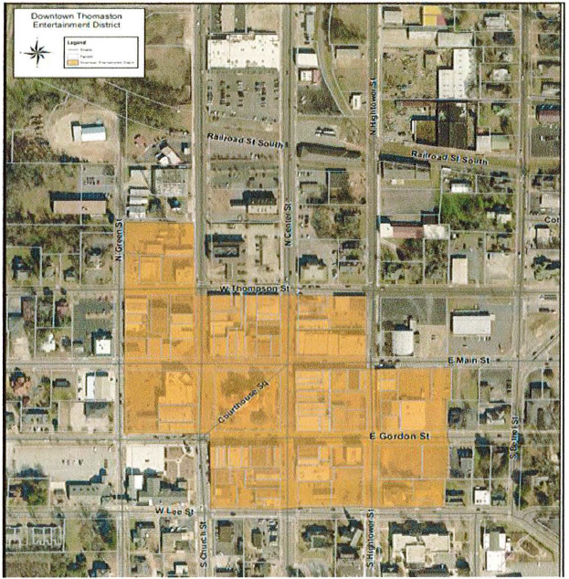
(a) There is hereby established an "entertainment district" within the city wherein open containers of alcoholic beverages shall be permitted.
(b) The restaurant district shall consist of the area contained in the yellow portion of the map set forth herein above and as illustrated on the "entertainment district map", including the sidewalks, rights-of-way and buildings therein.
(c) The following regulations shall apply to this section:
(1) Any establishment licensed to dispense alcoholic beverages by the drink for consumption on the premises is authorized to dispense alcoholic beverages in a plastic cup, for removal from the premises; provided, however, that no establishment shall dispense to any person more than one such alcoholic beverage at a time for removal from the premises.
(2) In accordance with section 62-12, it shall be unlawful to remove open containers of alcohol from the entertainment district as described in this section.
(3) All beverages shall be in a city provided container which said beverage containers shall be available for purchase from the City of Thomaston.
(4) No container in which an alcoholic beverage is dispensed and removed from the licensed premises shall exceed 16 fluid ounces in size. No person shall hold in possession on the streets and sidewalks, in parks and squares, or in other public places within the defined area any open alcoholic beverage container containing alcohol which exceeds 16 fluid ounces in size.
(5) It shall be unlawful for any person to drink or attempt to drink any alcoholic beverage from a can, bottle or glass or to possess in an open can, bottle, or glass any alcoholic beverage on the streets, sidewalks, rights-of-way, and parking lots, whether public or private.
(6) Consumption of alcoholic beverages described in this section shall be limited to the hours of 11:00 a.m. to 12:00 a.m. (midnight) seven days a week, unless approved by mayor and council for a special event.
(7) It shall be unlawful to consume any alcoholic beverage in the entertainment district, as described in this section, that was not purchased from a licensee or licensed vendor.
(8) Subsection (a) above does not apply to schools, churches, daycare facilities or anywhere private property owners or tenants do not allow it. A business may decline to allow an open container of alcoholic beverage on the premises by posting a sign that states, "Outside Drinks Not Allowed."
(9) It shall be unlawful for any person to drink or attempt to drink or to transport or attempt to transport any alcoholic beverages in an open container in any part of a motor vehicle within the entertainment district. This section does not limit the enforcement of, nor reduce the penalties for violation of section 17-61.
(Ord. No. 1159, 9-7-21)

Sec. 6-132—6-141. Reserved.

Note(s)—Effective January 1, 2022

